|  |  |  |
| --- | --- | --- |
| Qatar University  College of Engineering  Dept. of Computer Science & Engineering | quLogo94x89NT | Computer Programming  GENG106  Fall 2020 |

**In lab assignment - 4**

A user wants to purchase an iPhone at an affordable price, so he collected the names and prices of used iPhone 11 devices and stored them in the file iphones.txt.

The file contains records with the following format:

model(string)**\n**price (float)

Help the user get some statistics about the iPhone records by reading the file ‘iphones’ and performing the following tasks:

* Create a function called **iphone_statistics(file_name)** that prints the records of the iPhone with the following criteria:
  + The total number of records in the file.
  + The most expensive iPhone name and price.
  + The cheapest iPhone name and price (hint: initialize the cheapest price to 2000).
  + The average price of all iPhones in the file.
* Create a main function that calls the function iphone_statistics and passes the file name ‘iphones.txt’ as argument to it.

Your output should look like this:

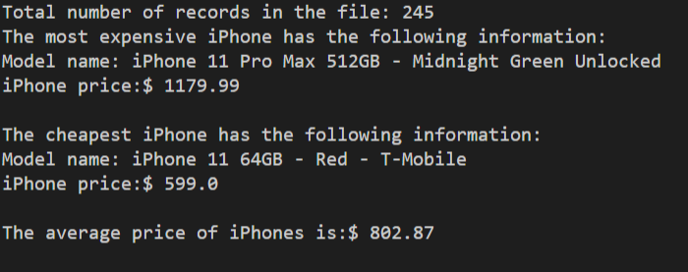

Submission instructions » Read carefully

1. Solve the question using Visual Studio Code by creating a .py file and writing your code in it.
2. Name your file *Assignment-4-Your Name-QUID.py*
3. Write your name and QU ID in your .py file as comments at the top of the file as well.
4. Take a screenshot of your program run and name it *Assignment-4-Your Name-QUID.png*.
5. Submit both your **.py** and **.png** file to Blackboard.